(DHANKAWADI, PUNE-43)



MINI PROJECT REPORT ON

“Internship Management System”

SUBMITTED BY

Bhumi Kamble (3027)

Mahesh Jadhav(3023)

Pratik Jaiswal (3024)

Saylee Marulkar(3034)

(Third Year Information Technology)

UNDER THE GUIDANCE OF

Prof. S. A. Jakhete

Submitted To

**Pune Institute of Computer Technology**

**For Academic Year 2017-18**

|  |  |
| --- | --- |
| **TITLE** | **PAGE NO** |
| **1. Introduction** | **3** |
| **2. Scope and limitations** | **4** |
| **3.Flow Diagram** | **5** |
| **4. E-R Diagram (description)** | **6** |
| **5.Normalization(up to 3NF)** | **7** |
| **5. coding -Procedure and Triggers, view Design (description)** | **8** |
| **5. coding design(form snapshot)** | **9** |
| **6.User Interface Snapshots** | **13** |
| **7.Conclusion** | **29** |

# INTRODUCTION

Internship Management System is a portal which consists of providing opportunities to students of various academic backgrounds by offering them internships in various domains and areas of interest. The internships are offered by companies which are well reputed in their domain and have a specific judging criteria. The internships are offered in various domains like IoT(Internet of Things), Game Development and Accounting. Each student has to create his/her profile and apply to the company of interest. Then accordingly, if the student satisfies the company’s academic criteria, he/she can appear for a quiz examination which upon clearance will enable him/her to apply for the last stage. Similarly, the HR manager of the company has to create his/her company’s profile and account and handle all the internship activity which is done by the respective students.

# SCOPE

This software can be developed for a more competitive and unique internship application portal in future.

For e.g.

1. The software can be used by every university/ college which desires to provide internships for their students and their graduates.
2. Software is made for centralized information maintenance of Internships offered by the company in the field of specific domain.
3. Central administrator has the control on all the activities, w.r.t. adding ,deleting, modifying database information and accessing the daily information of students who are applying for the internship
4. Each Student and Manager has their own login. The whole procedure of offering an internship is going to be controlled by the admin or in this case, the manager of the company.
5. The software can be more customized and comprehensive and can be used by any company to offer an internship and set various judging parameters to test the applicant’s capability.

# LIMITATIONS

1. There are limited parameters upon which a student is judged.
2. A student can apply for one internship at a time.
3. The judging procedure is not competitive enough.

The main modules in this Project are as follow

* STUDENTS
* MANAGER
* AREA OF INTEREST OR DOMAIN
* INTERNSHIPS OFFERED
* QUIZ

# E-R Diagram

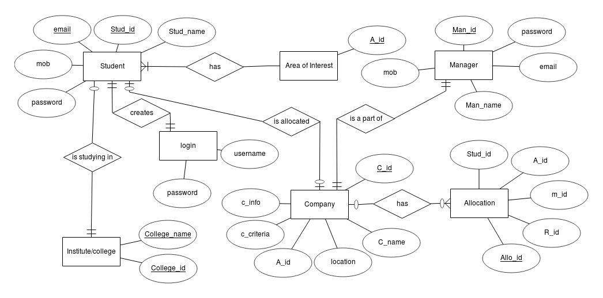

# Flow diagram

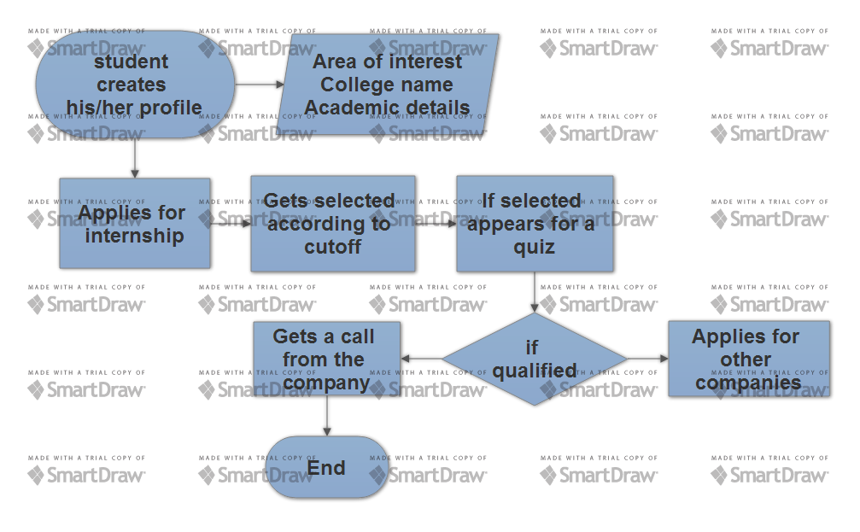

# **SCHEMA DEFINITION**

# **Table list**

# 

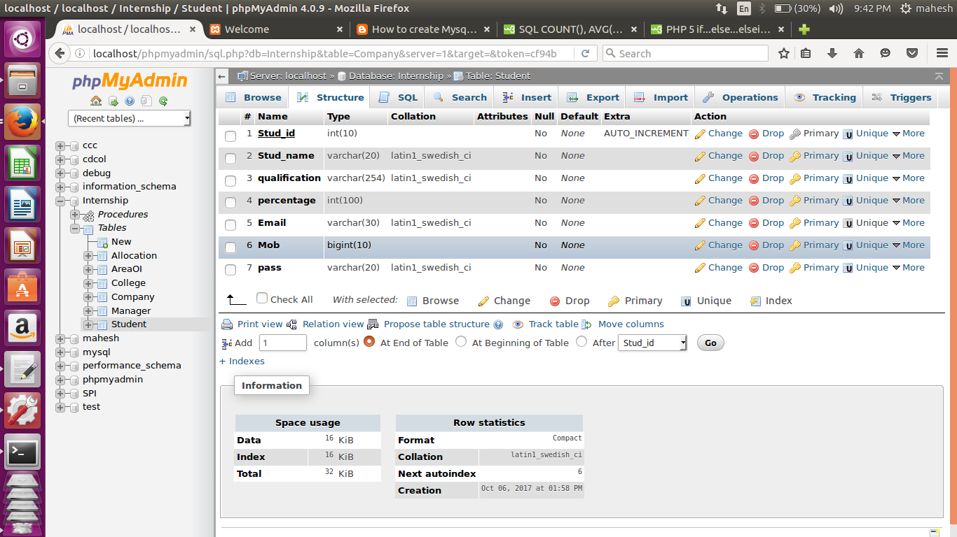

# 

# **CODING**

# **Procedures Used**

# 

# **User interface snapshots**

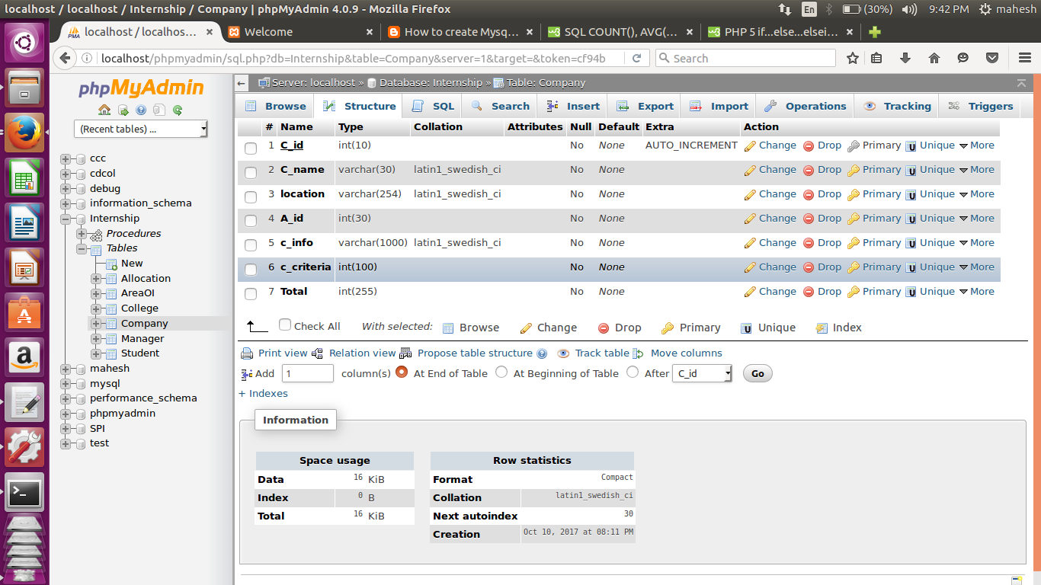

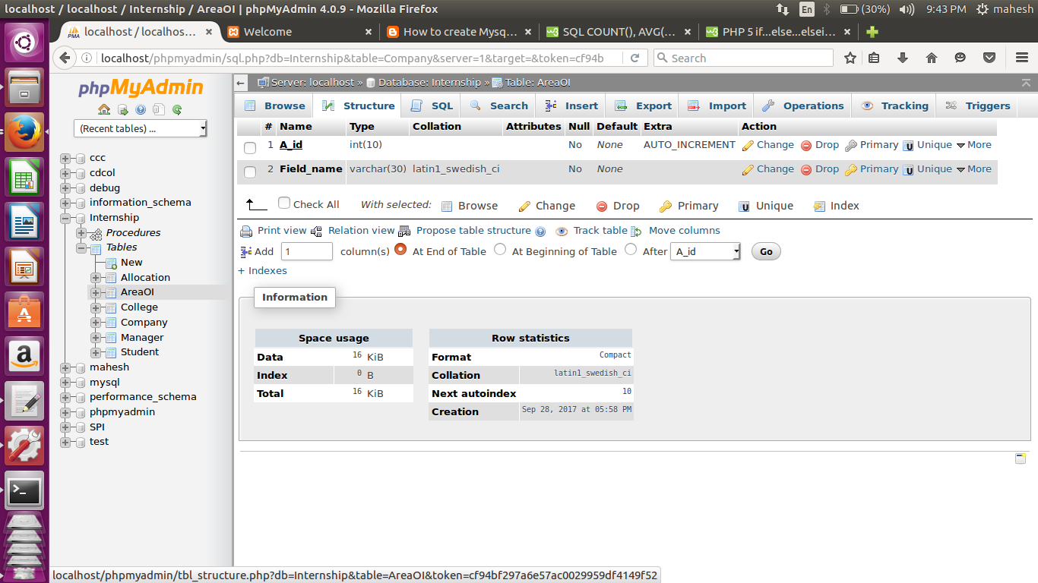

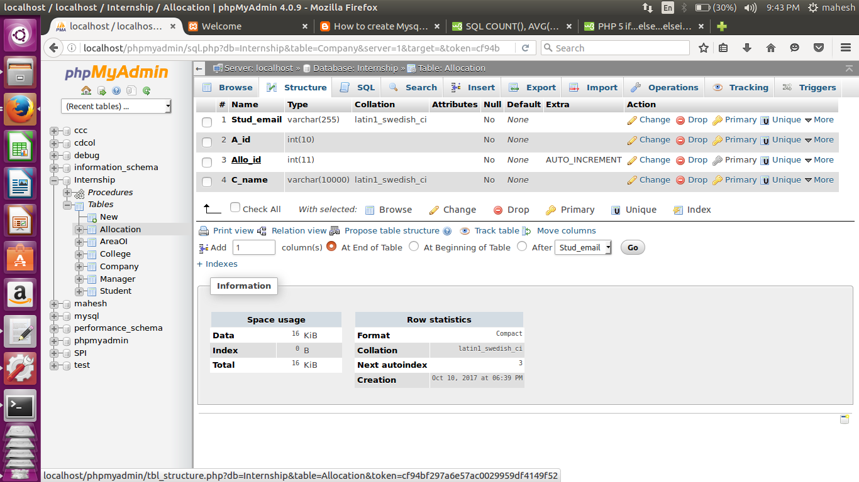

CODING

Procedures Used:

1. Procedure for calculating total number of students

create or replace procedure counts() is

begin

select * from Student;

end

2. Procedure for counting total number of students

create or replace procedure totalcount() is

begin

select count(*) from Student;

end

3. Procedure for calculating number of students who got internship in respective companies

create or replace procedure internship() is

begin

select * from Allocation;

end

2. Procedure for counting total number of students who got the internship

create or replace procedure internshipcount() is

begin

select count(*) from Allocation;

end

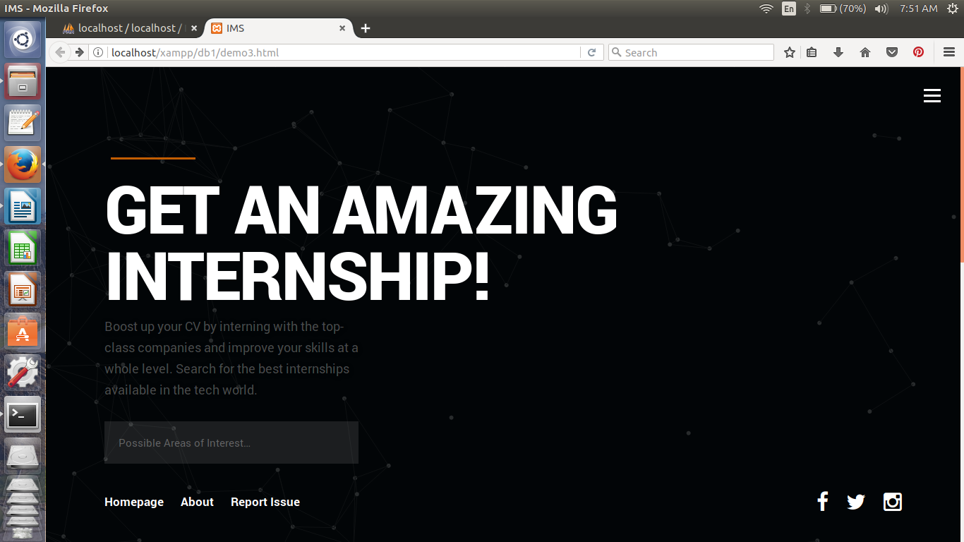



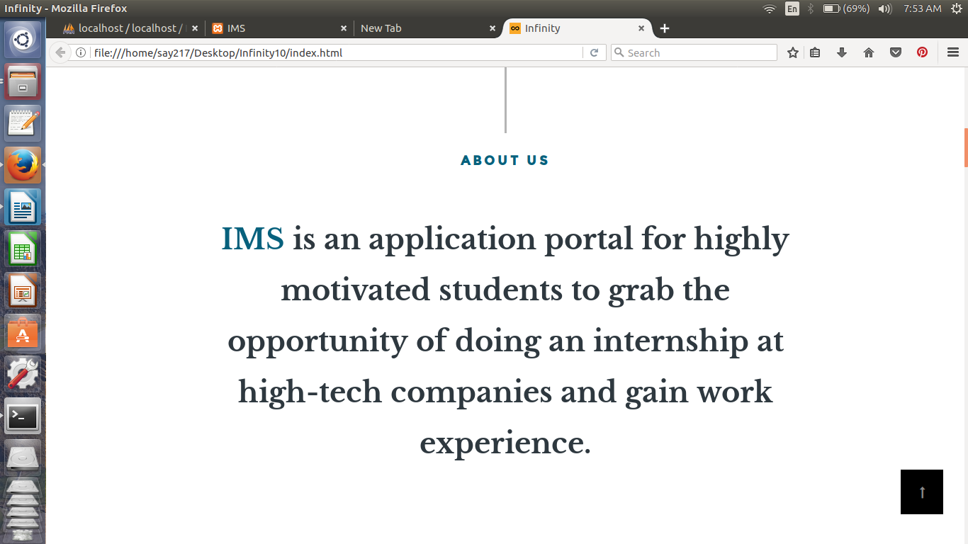

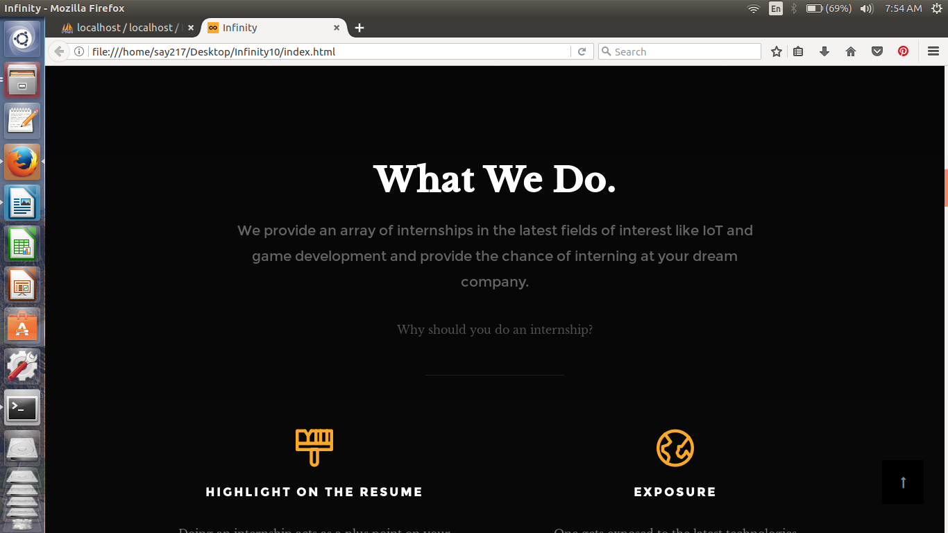

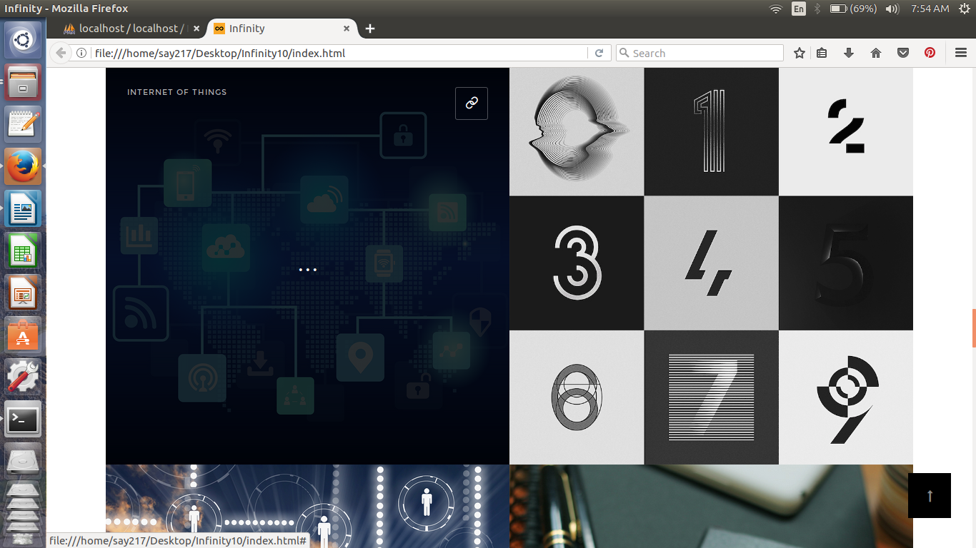

# 

# 

# CONCLUSION

The three parts which are essential for this project are User interface, Creation of relational database and SQL engine.

The Project is entirely based on database management system concepts. The back-end use for project is MySQL and front-end is PHP, HTML, CSS. The Coding of Sql queries through PHP is properly performed and a selection sort has been applied to match the applicant's area of interest with the internships offered . The project is very feasible.

The software engineering concepts are used to implement the project. The requirement analysis is understood and done for this project.